**University of Technology (Yatanarpon Cyber City)**

**Faculty of Information and Communication Technology**

**Earth’s Health**

**Nyein Chan Aung, Htet Wai Aung, Thet Htar Aung, Ei Phy Moe, Thet Ngone Htoo,**

**Yin Zarni Po Po Oo, Phue Wai Wai Kyaw, Yoon Mi Mi Kaung**

**Supervisor- Daw Myint Myint Khine**

1. **Introduction**

Our project, website, is an environmental website and we give you a lot of knowledge about environment. Our earth is changing more and more. So, we need to save our earth. You can learn many saving method form our website.

**Key Words:** environment, earth’s health, world

1. **Aims & Objectives**

Earth’s Health is our health. Our website aim for sharing information. We also want to help our earth with our profession. If someone see our website and have a mind to take care, this is our objective. We can give you saving and protecting easy ways which everyone can do. We need to save public land in public hands.

1. **System Design & Operation**

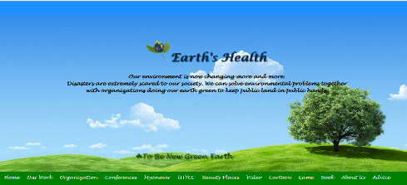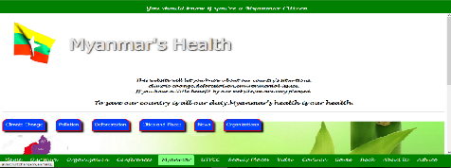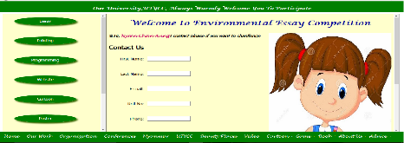

1. **Results, Discussion & application**

Our website will give a lot of helps for environment. As we describe current situations, people will know what is happening in our environment in time. We also add games, videos, cartoons about environment. So even children can also learn saving methods from our website.

1. **Conclusion**

As conclusion, you can learn a lot of environmental knowledge from our website and you can also protect our earth together with us. Take care, our environment is in our hand and it needs a lot of aids from us. Let’s protect together.

1. **Applied Theory/Software**

HTML-5, JavaScript,Notepad++

**Project Name – Earth’s Health**

**Major- Information and Communication Technology (ICT)**

**Year- Second Year**